- What are support vectors in SVM?
- What are Hard-Margin and Soft-Margin SVMs?
- WHat is kernel trick and how it is important?
- Give some situations where you will use an SVM over a RandomForest Machine Learning algorithm.
- What is the role of C in SVM? How does it affect the bias/variance trade-off?
- SVM being a large margin classifier, is it influenced by outliers?
- Can we apply the kernel trick to logistic regression? Why is it not used in practice then?
- What is the difference between logistic regression and SVM without a kernel?
- The training examples closest to the separating hyperplane are called as
- Which SVM model is more suitable for non-linearly separable data?

==========================================================================
- Support vectors are the data points nearest to the hyperplane, the points of a data set that, if removed, would alter the position of the dividing hyperplane.
Using these support vectors, we maximize the margin of the classifier.
For computing predictions, only the support vectors are used.
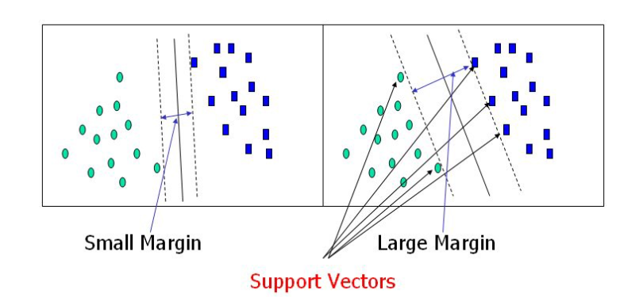
- Hard-Margin SVMs have linearly separable training data. No data points are allowed in the margin areas. This type of linear classification is known as Hard margin classification.
Soft-Margin SVMs have training data that are not linearly separable. Margin violation means choosing a hyperplane, which can allow some data points to stay either in between the margin area or on the incorrect side of the hyperplane.
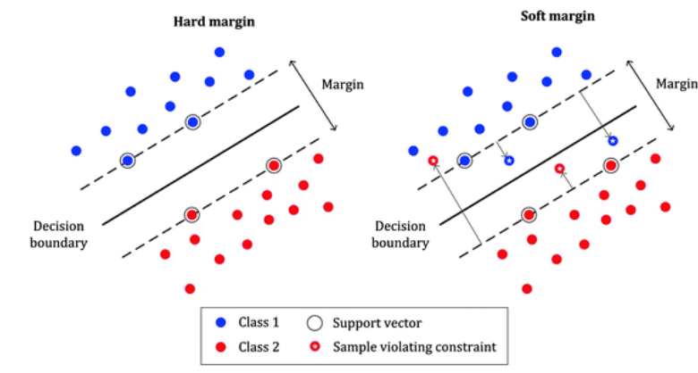
3)The idea is to map non linear data into higher dimensional where we can find a hyperplane that can separate the samples.
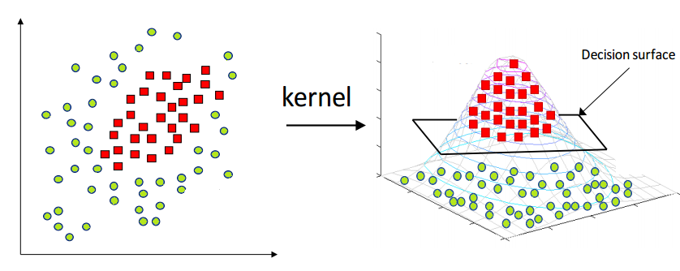
It reduces the complexity of finding the mapping function. So, Kernel function defines the inner product in the transformed space. Application of the kernel trick is not limited to the SVM algorithm. Any computations involving the dot products (x, y) can utilize the kernel trick.
4)The main reason to use an SVM instead is that the problem might not be linearly separable. In that case, we will have to use an SVM with a non-linear kernel (e.g. RBF).
Another related reason to use SVMs is if you are in a higher-dimensional space. For example, SVMs have been reported to work better for text classification.

5)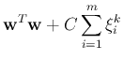
In the given Soft Margin Formulation of SVM, C is a hyperparameter.
C hyperparameter adds a penalty for each misclassified data point.
Large Value of parameter C implies a small margin, there is a tendency to overfit the training model.
Small Value of parameter C implies a large margin which might lead to underfitting of the model.
6) Yes, if C is large, otherwise not.
7)Logistic Regression is computationally more expensive than SVM — O(N³) vs O(N²k) where k is the number of support vectors.The classifier in SVM is designed such that it is defined only in terms of the support vectors, whereas in Logistic Regression, the classifier is defined over all the points and not just the support vectors. This allows SVMs to enjoy some natural speed-ups (in terms of efficient code-writing) that is hard to achieve for Logistic Regression.
8)They differ only in the implementation . SVM is much more efficient and has good optimization packages
9)Support vectors
10)Soft margin classifier

